
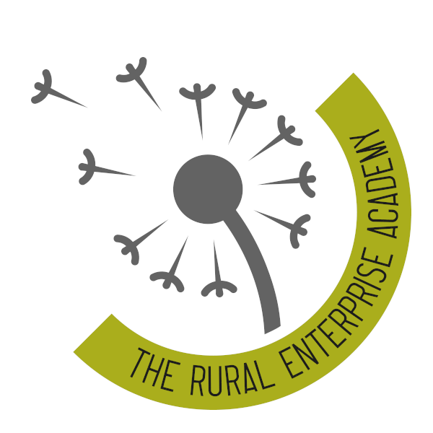

28th April 2025

Dear Parents and carers,

I hope this letter finds you well. My name is Annabel Stoddart, and I am delighted to introduce myself as the new Headteacher of The Rural Enterprise Academy. It is with great pleasure that I return to my roots, having previously served as Headteacher at two other schools, including Abbot Beyne in Staffordshire.

Coming back home to lead this wonderful academy is a privilege, and I am excited about the journey ahead. I am committed to working in partnership with you to bring about the improvements necessary to ensure our children receive the education and outcomes they deserve.

I look forward to meeting and engaging with each of you as we embark on this new chapter together. Your support and collaboration will be invaluable as we strive to create an environment where every student can thrive.

Thank you for your warm welcome. Together, we will achieve great things for our children and our community.

Best wishes,

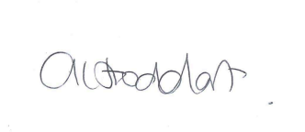

Annabel Stoddart
Headteacher
The Rural Enterprise Academy

